

**JONA SAM NDEMULONGA**

**Curriculum Vitae**

**Personal Profile**

To apply my skills in an interesting and challenging way that would enable me to advance my knowledge and apply my skills to the benefit of the institution/firm/company or organisation while displaying my own knowledge. A commitment to uphold the

principles of professionalism and good ethical conduct

**working Experience**

# Contact

**e** +264 ai 3714748

**Jowen Construction**

Electrician

**22 July 2021· Present**

**Q** ERF 121,Jordan street, Pionierspark Windhoek Namibia

PO Box 30618, Windhoek

**O** [ndemulongasamson@gmail.com](mailto:ndemulongasamson@gmail.com)

**Driver's License:** Code Cl

* Installing, and repairing electrical control, wiring, and lighting systems.
* Reading technical diagrams and blueprints
* Plan layout and installation of electrical wiring, equipment and fixtures, based on job specifications

**Shafa Engineering Group**

# Education

Electrician Intern

* Supervision of renovations projects.

**10 Jan 2019-28 June 2021**

1. **Windhoek Vocational Training**

**center 2020**

National Vocational Certificate in Electrical General / / L3

1. **David Sheehama Senior secondary School 2014**

Namibia Senior Secondary Certificate

# Languages

* Attend all tender compulsory meetings, minute the meetings, and provide feedback reports to engineers.
* Residential Construction Projects;
* General Maintenance works;
* Workshop supplies and Tool Register record keeping;
* Attend to emergency call outs;
* Basic Architectural and Engineering drawing understanding
* Residential electrical fault findings

**Namibian Port Authority (NAMPORT)**

Good in English and Oshiwambo,

# References

1. Mr Shipombo limanuel Manager

Electrical Intern

* + Maintenance on electrical Field

# Skills

* + Industrial Experience

**24 June 2018- 24 Sept 2018**

Shafa Engineering

### +264812788015

1. Mr Godfredy Ngalazi Supervisor

Jowen Construction

### +264812386075

* + Install and Maintain Electrical Equipment, Systems, and Devices
  + Installing Fixtures and Electrical Components at Construction Sites
  + Laying Out and Installing Wiring Circuits
  + Maintaining Tools and Equipment
  + Repair Electrical Systems
  + Repair Wiring Systems, Electrical Conduit, and Related Equipment
  + Repairing Single and Polyphase Wiring Systems
  + Replacing Defective Wiring Systems

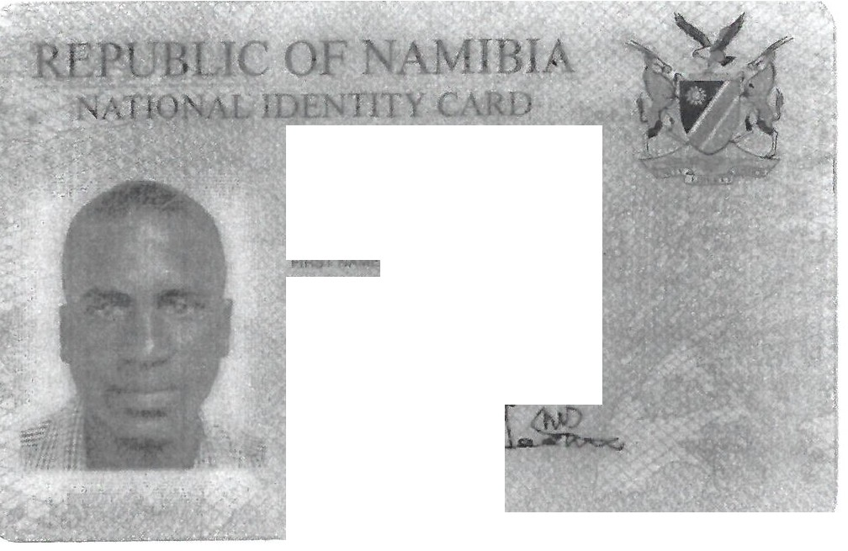

**940304 0090 6**

€

**JONA**

**SAM NDEMULONGA**

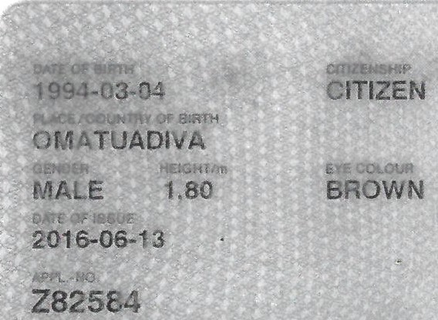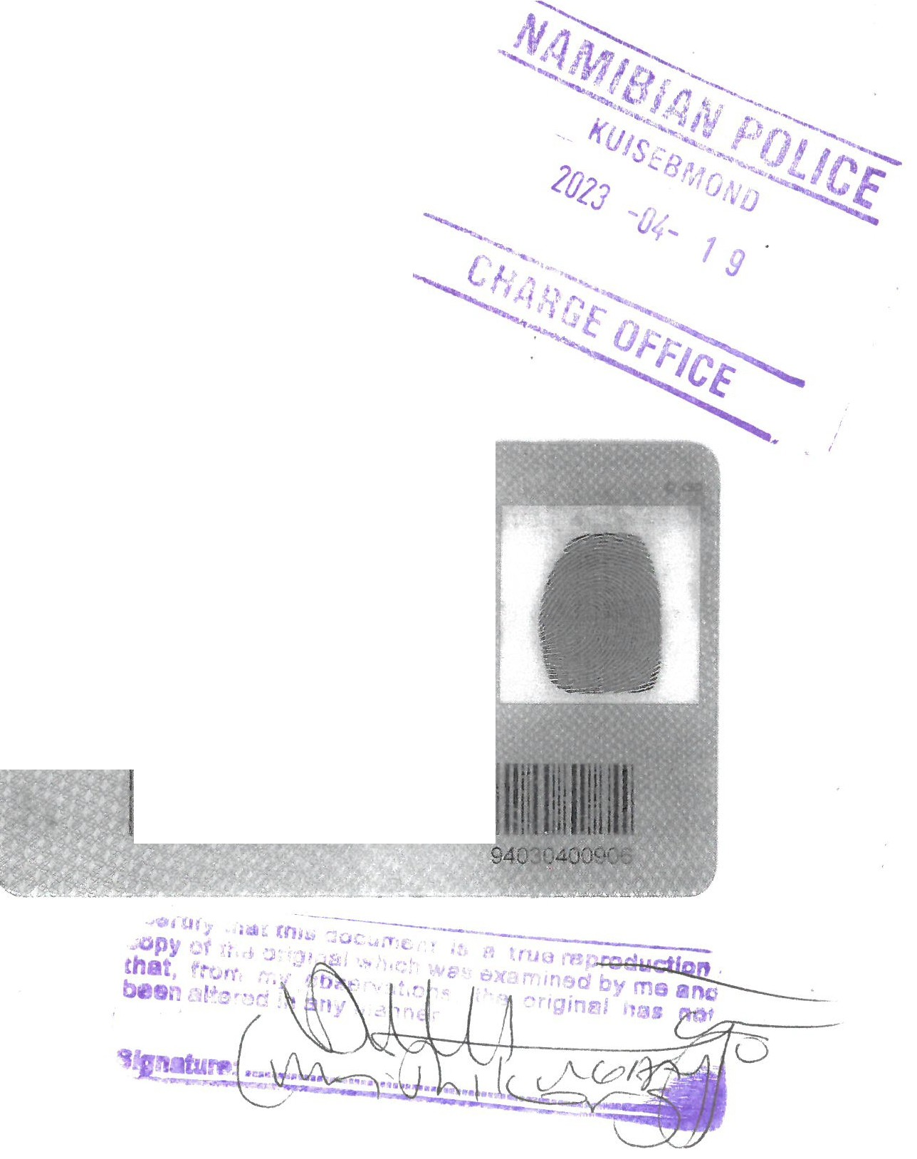

11111I 1111111fflllllllllllllIllII



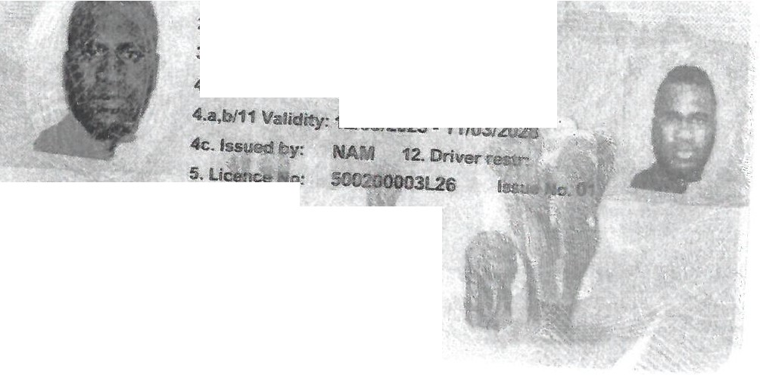

1. Surname:
2. Names:

JONA

SAM NDEMULONGA

3. Date of 8irth: 04/03/1994 Male

03/94030400906

9. Code:

5. licence

C1

10. First Issue: 10/0312023

12. Vehicle restr:

7.

.£;,,,:,,

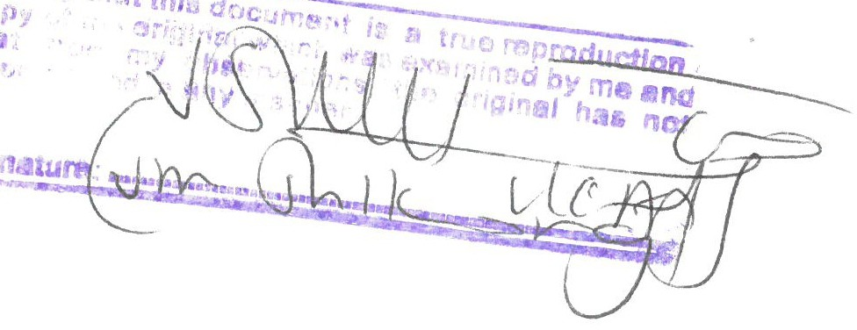

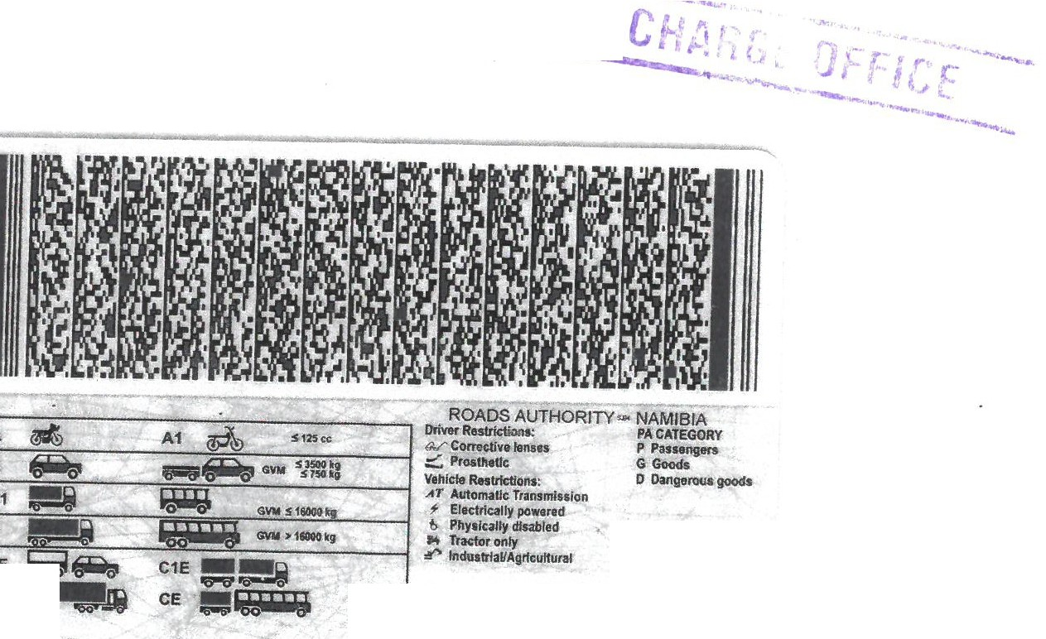

-

3141581

: BE

CE

101440785

lllll11111111111111111111111





f' - •

**National Trades Certlficate**.-.tE '-

t, '' '

**Level3**

### It is hereby certified that

**Sam Ndemulonga Jona**

**ID NO: 94030400906**

## has fulfilled the requirements •

for the National Vocational Qualification Level 3

m

**Electrical Engineering**

**Electrical General**

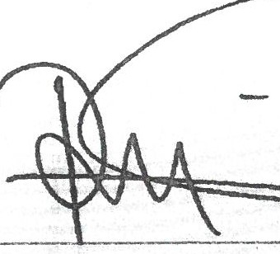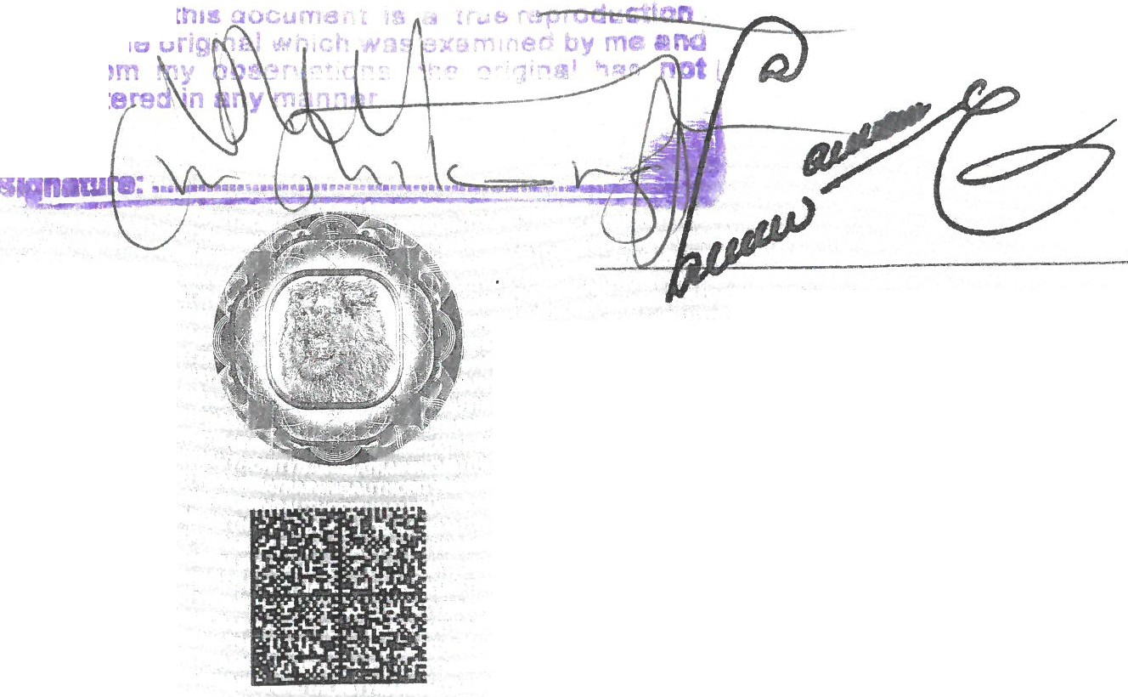**..orory ,mu**

**.x,py of·**

**thet, fr**

_,**baenal**

Chairperson: Standards, Assessment & Certification Council

The conditions or award are printed overleaf.

This *is* a secure document using special papers and inks.

Chairperson:

Namibia Training Authority Board Date of Issue: November 2020

### TRN 11301001100112011

This certi6CJ11te *is* issued without any erasures or alterations.

Hold to the light to verify the watermark and the "GENUINE" embedded thread can be seen through the paper.

EE/EG/3

0009 58 4

*S* & 0 - *Z09S0.0Z* • *ZIZ0*

*j*

-' ':"'

'/ *·1* 1

**:-.AMIBIA** TAAINI 'C AUTHORITY

**STATEMENT OF ACHIEVEME f---(111)**

SURNAME: Jona --- ::. :' ,

FIRST NAME: Sam Ndemulonga ;I,,• f,._•.', j .. *t*

#### I.D. NUMBER: 94030400906

EXAMINATION NUMBER: 7130/001/001/2017

TRADE *I* COURSE: Electrical General

MONTH OF ASSESSMENT November 2020

ASSESSMENT RESULTS:

..*,ort:..;*



, I *1* (l

*J*

Pass Requirements: Theoretical Subjects - 40 % Practical Skills - 60 % THEORETICAL TEST RESULTS: PRACTICAL TEST RESULTS:

Subject % Skills Assessed Possible Marks % Obtained

|  |  |  |  |  |
| --- | --- | --- | --- | --- |
|  | | Marks | Obtained | Obtained |
| 1. | ELECTRICAL | 100 | 87 | 87 |
| 2. | INSTALLATION WORK  PANEL WIRING+ FAULT | 100 | 86 | 86 |
| 3. | FINDING  MOTOR+ STARTER | 100 | 76 | 76 |
| 4. | CURRENT AND | 100 | 89 | 89 |
| 5. | PONTENTIAL  SINGLE PHASE | 100 | 90 | 90 |
|  | FORWARD REVERSE |  |  |  |
| 6. | CAM  THREE PHASE MOTOR | 100 | 93 | 93 |
|  | TEST REPORT |  |  |  |

1. TRADE THEORY 65

#### MATHEMATIC 50

#### TECHNICAL 65

#### DRAWING

#### ENGINEERING 41

#### SCIENCE

TOTAL: AVERAGE:

221

55%

#### TOTAL: AVERAGE:

**REMARKS:** PASS

600 521

87%

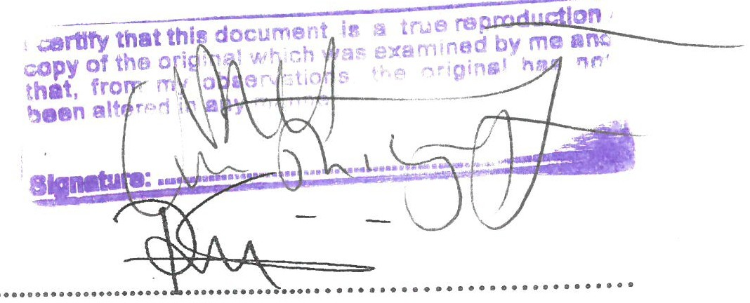

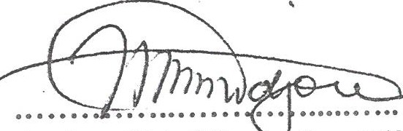Acting Chief Exe tive Officer Namibia Training Authority

Chairman:

Standards, Assessment & Certification Council



 

**1':AMIBIA TRAINING AUTJIORln'**

*r* . .

STATEMENT OF ACHIEVEM NT'ttl

**SURi'l'AME FIRST NAME I.D.NUMBER**

**EXAMINATIOl'- NUMBER**

**TRADE/COURSE**

**MONTH OF ASSESSMENT**

**Jona**

**Sam Ndemulonga**

94030400906

**7130/001/001/2017**

**Electrical General June** 2019

ASSESSMENT RESULTS:

Pass Requirements: Theoretical Subjects - 40 % Practical Skills -- 60 o

THEORETICAL TEST RESULTS: PRACTICAL TEST RESULTS:

|  |  |  |  |  |  |  |
| --- | --- | --- | --- | --- | --- | --- |
| Subject % Skills Assessed Possible | | | | | Marks % | |
|  | Obtained |  | | Marks | Obtained | Obtained |
| 1. **TRADE THEORY**  **MATHEMATICS** | 43  52 | 1. ELECTRICAL   **INSTALLATION WORK**   1. **PANEL WIRING+** | | 100  100 | 83  68 | 83  68 |
| **ENGINEERING** | 66 | **FAULT FINDING**  3. **DIRECT ON LINE** | | 100 | 76 | 76 |
| **DRAWING**  **ENGINEEING** 57 4. | | | **MOTOR+ STARTER THREE PHASE MOTOR** | 100 | 69 | 69 |
| **SCIENCE** | | **TEST REPORT**  5. **THREE PHASE** | | 100 | 45 | 45 |
|  | | **FORWARD/RESERVES** | |  |  |  |
|  | | **PANEL**  6. **FIVE HEAT STOVE** | | 100 | **88** | **88** |
|  | | **SWITCH** | |  |  |  |

**TOTAL: AVERAGE**

229

57%

**TOTAL: AVERAGE:**

600 429

72%



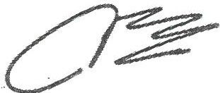Chief Executh-e Officer Namibia Training Authority

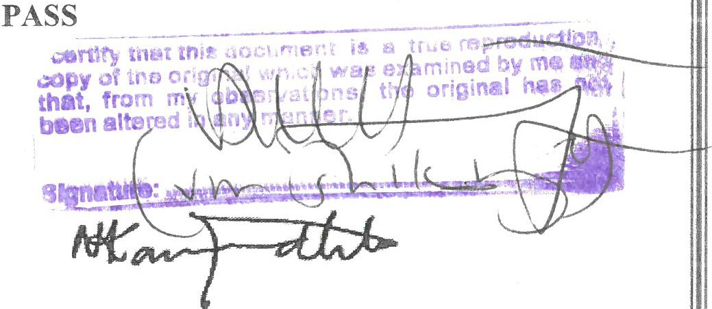

.........................................................

Chairman:

Standards, Assessment & Certification Council

* '

!*.::*rJf"fil',:_

7

:-.A IIBIA TMl:-.t:...G Alfft IORITY

NATIONAL ASSESSMENT CENTRE

PO Box 70407, Khomasdal Tel: ( 061) 2078200 Fax: ( 061) 2078550

SURNAME: FIRST NAME:

ID NUMBER: EXAMINATION NUMBER:

TRADE *I* COURSE: TRAINING PERIOD:

STATEMENT OF ACHIEVEMENT (I)

Jona

Sam Ndemulonga 94030400906

7130/001/001/2017

ELECTRICAL GENERAL

From: 2017 To:

2017

#### ASSESSMENT RESULTS:

Pass Requirements: Theoretical Subjects - 40 %

Practical Skills - 60 %

THEORETICAL TEST RESULTS:

Subject %

Obtained

1. TRADE THEORY 70
2. MATHEMATICS 65
3. TECHNICAL DRAWING 93
4. ENGINEERING 88

SCIENCE

PRACTICAL TEST RESULTS:

Skills Assessed Possible Marks Marks Obtained

1. ELECTRICAL 100 86

INSTALLATION

1. P.E.C. SODIUM VAPOUR 100 95

LAMP

1. THREE HEAT STOVE 100 91

SWITCH

1. FLORESCENT LAMP 100 89

**WITH** SINGLE TUBE

|  |  |  |  |  |  |  |
| --- | --- | --- | --- | --- | --- | --- |
|  | | 5. | TESTING OF A CIRCUIT | 100 | 78 | 78 |
| TOTAL | 316 |  | TOTAL | 500 | 439 |  |

%

Obtained

86

95

91

89

AVERAGE 79%

AVERAGE

88%

REMARKS: Pass

Chief Executive Officer Namibia Training Authority

·········· ····"

, *Nt*

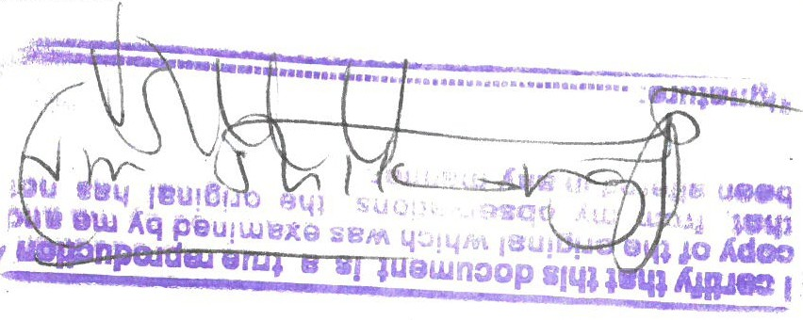*·························c ;:1;t ;*•••••••••••••••••

Standards, Assessment & Certification Council



Republic of Namibia

This is to certify that the candidate named below was awarded the following grade(s) for the subject(s) shown in the examination of October/November 2014.

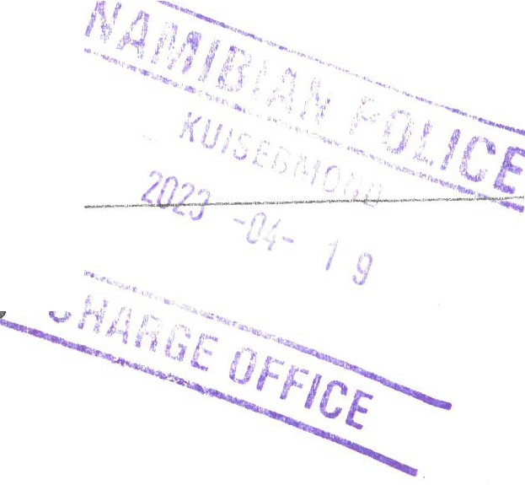

**Ministry of Education**

.........

**Namibia Senior Secondary Certifica**

**(Subject Award)**

SAM N JONA

Date of Birth: 04 March 1994

**Subject**

First Language Oshikwanyama Mathematics

Physical Science Biology

English as a Second Language Geography

SUBJECTS RECORDED: SIX

**Level** Higher Ordinary Ordinary

Ordinary Ordinary Ordinary

**Grade** 4(FOUR) D(d)

D(d)

F(f)

F(f)

F(f)

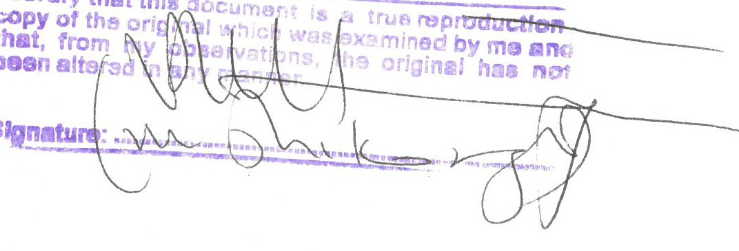

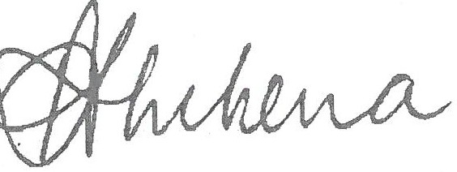 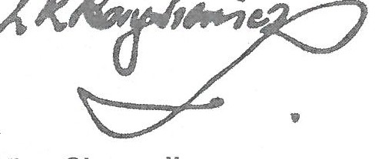

**Permanent Secretary**

Ministry of Education, Namibia

**Vice-Chancellor**

University of Cambridge

in collaboration with

**University of Cambridge Local Examinations Syndicate**

Candidate Number: NAO89/0163 Certificate Number: 147106144

*,...,,.,,0?* :r:. --:'=;·'. ;,

"' : j

-.

*.:,:-.*

**CAMBRIDGE** *- ,(*

"

.... •.·.

; ,

## International Examinations

.,,,,,., ,.-,, *'1*

* ,"

**0000.5181**



P.O Box 8432, Bachbrecht, Windhoek 63 Daffodil Street, Windhoek [info@shafaengineeringcc.com](mailto:info@shafaengineeringcc.com)

15th July 2021

**Jo Whom It May Concern**

This letter serves to inform you that Mr Jona Sam N, ID No: 94030400906 has been working for Shafa Engineering cc since 14 May 2018 as a trainee from Windhoek Vocational Training, specializing in Electrical General.

In January 2019 he got employed as permanent employee (he was a full-time at work and part-time at school in 2019) to 28 June 2021.

Key areas in which work exposure and experience were provided include:

* Supervision of renovations projects.
* Attend all tender compulsory meetings, minute the meetings, and provide feedback reports to engineers.
* Residential Construction Projects;
* General Maintenance works;
* Workshop supplies and Tool Register record keeping;
* Attend to emergency call outs;
* Basic Architectural and Engineering drawing understanding;
* Residential electrical fault findings;
* Swimming pools - servicing, and;
* Construction Quotes preparations.

He is a valuable employee and would be great positive asset addition to any organization.

Should you need any additional information regarding his candidacy, please do not hesitate to contact me.

Your faithfully

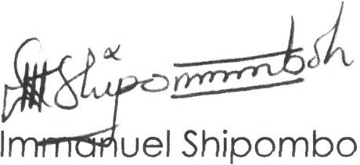

**Mechanical Engineer, (IE2017-5)**

For **SHAFA ENGINEERING cc**

immanuel@shafaenqineerinqcc.com or immanuel@shipombo.com Cell: +264 81 278 8015

